**HTML FORM**

An HTML form is a type of structure that is the main purpose of to collect user input. The user input is most often sent to a server for processing.

The <form> element is a container for different types of input elements, such as: text fields, checkboxes, radio buttons, submit buttons, etc.

The main two attribute of form.

* **Method**

Method is nothing but it is a different type way to send data on a server.

* GET Method
* POST Method

<form method="get">

* **Action**

Action URL contain those URL where we want to send data. Basically when we send data on server we need to maintain URL of that server in action attribute

<form method="get" action=”index.php”>

**The <form> Element**

* The HTML <form> element is used to create an HTML form for user input:
* The <form> element is a container for different types of input elements, such as: text fields, checkboxes, radio buttons, submit buttons, etc.

## <input> Element

An <input> element can be displayed in many ways, depending on the type attribute.

And it contain two type of attribute.

1. **<input type="text">:** It is use to take input text from user. Also note that the default width of text input fields is 20 characters

**Example: <input type=”text” name=”” value=”” id=””>**

* **Type attribute:-** when we create input tag we have to specify type attribute because type attribute decide which type of input element you want to create.

**<input type="text”>// here input is a tag , type is a attribute and text is predefined value.**

* **Name attribute:-** name attribute is use to help the server to store the data in right place. Suppose we have two input box first one is Firstname and second one is Lastname user can easily understand and give input. But server can’t understand where store the data given by user so we have to dealer name attribute then server store the data according to name attribute.

***FirstName<*input type="text" name="Firstname"*>***

***LastName<*input type="text" name="Lastname"*>***

* **Value attribute:-** value attribute Is use to show pre-written value in input text box.



***<*input type="text" id="ram"value="user-name" name="ram"*>***

**.Example**

*<*form*>*

*<*label for="fname"*>*First name:*</*label*><*br*>*

*<*input type="text" id="fname" name="fname"*><*br*>*

*<*label for="lname"*>*Last name:*</*label*><*br*>*

*<*input type="text" id="lname" name="lname"*>*

*</*form*>*

1. **<input type="password">:** It  is use to take input password from user. In this type of value all text are hidden.
2. **<input type="radio">:** It defines a radio button. Radio buttons provide limited number of choices for user to select ONE option from a limited number of choices.

*<*form*>*

*<*input type="radio" name="rahul"*>*

*<*label for="Job"*>*full time*</*label*><*br*><*br*>*

*<*input type="radio" name="rahul"*>*

*<*label for="Job"*>*part time*</*label*>*

*</*form*>*

1. **<input type="CHECKBOX">:** It defines a checkbox. Check-box provide limited number of choices for user to select ZERO or MORE options from a limited number of choices.

*<*form*>*

*<*legend*>*Topic Of Intreast*</*legend*>*

*<*input type="checkbox" name="checkbox" id="checkbox" */>*

*<*label for="checkbox"*>*HTML*</*label*>*

*<*input type="checkbox" name="checkbox" id="checkbox" */>*

*<*label for="checkbox"*>*css*</*label*>*

*<*input type="checkbox" name="checkbox" id="checkbox" */>*

*<*label for="checkbox"*>*java*</*label*>*

*</*form*>*

1. **<input type="file">:** this value is used to user can upload the file.

*<*input type="file" id="fileupload" name="fileupload"*><*br*>*

**button**

**<input type="submit">:**  It defines a button for submitting the form data. when we click on submit button it pass all the data of form to the server.

**<input type="reset"> : it** defines a **reset button** that will reset all form values to their default values:

**<input type="image">:** It defines an image as a submit button. When user click on image button it pass the information to the server.

**Note :- we can create button in html form with the help of input element as well as button tag.**

*<*input type="button" value="ram"*>here input is tag , type is a attribute and value is the name of button*

*<*button*>*Reset*</*button*>*

**<input type="color">**: It is used for input fields that should contain a color. Depending on browser support, a color picker can show up in the input field.

*<*form*>*

*<*label for="favcolor"*>*Select your favorite color:*</*label*>*

*<*input type="color" id="favcolor" name="favcolor"*>*

*</*form*>*

The <input type="date"> is used for input fields that should contain a date.

<form>  
  <label for="birthday">Birthday:</label>  
  <input type="date" id="birthday" name="birthday">  
</form>

The <input type="datetime-local"> specifies a date and time input field, with no time zone.

<form>  
  <label for="birthdaytime">Birthday (date and time):</label>  
  <input type="datetime-local" id="birthdaytime" name="birthdaytime">  
</form>

The <input type="image"> defines an image as a submit button.

The path to the image is specified in the src attribute.

<form>  
<input type="image" src="img_submit.gif" alt="Submit" width="48" height="48">  
</form>

[Try it Yourself »](https://www.w3schools.com/html/tryit.asp?filename=tryhtml_input_image)

The <input type="month"> allows the user to select a month and year.

<form>  
  <label for="bdaymonth">Birthday (month and year):</label>  
  <input type="month" id="bdaymonth" name="bdaymonth">  
</form>

The <input type="number"> defines a **numeric** input field.

You can also set restrictions on what numbers are accepted. With the help of min and max attribute

<form>  
  <label for="quantity">Quantity (between 1 and 5):</label>  
  <input type="number" id="quantity" name="quantity" step="10" value="30" min="1" max="50">  
</form>

<input type="range"> defines a control for entering a number whose exact value is not important (like a slider control). Default range is 0 to 100. However, you can set restrictions on what numbers are accepted with the min, max, and step attributes:

<form>  
  <label for="vol">Volume (between 0 and 50):</label>  
  <input type="range" id="vol" name="vol" min="0" max="50">  
</form>

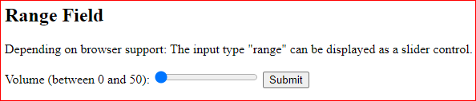

The <input type="tel"> is used for input fields that should contain a telephone number.

<form>  
  <label for="phone">Enter your phone number:</label>  
  <input type="tel" id="phone" name="phone" pattern="[0-9]{3}-[0-9]{2}-[0-9]{3}">  
</form>

**<textarea cols="10" rows=”20”>**

The <textarea> tag defines a multi-line text input control. The <textarea> element is often used in a form, to collect user inputs like comments or reviews. The size of a text area is specified by the cols and rows attributes.

*<*textarea name="comment" id="comment" cols="25" rows="2"*></*textarea*>*

**The <select> Element**

The <select> element defines a drop-down list: and option element define the inside of select element. Basically The <option> elements defines an option that can be selected. By default, the first item in the drop-down list is selected.

### Example

*<*label for="cars"*>*Choose a car:*</*label*>*

*<*select id="cars" name="cars"*>*

*<*option value="volvo"*>*Volvo*</*option*>*

*<*option value="saab"*>*Saab*</*option*>*

*<*option value="fiat"*>*Fiat*</*option*>*

*<*option value="audi"*>*Audi*</*option*>*

*</*select*>//value attribute is use to store data on server*

* If you want to select random item as a first item of dropdown list you have to use selected attribute

<option value="fiat" selected>Fiat</option>

* Use the size attribute to specify the number of visible values: <select id="cars" name="cars" size="3">

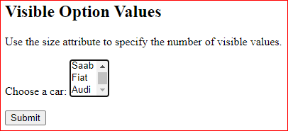

* Use the multiple attribute to allow the user to select more than one value:

Hold down the Ctrl (windows) button to select multiple options.

<select id="cars" name="cars" size="4"multiple>

* . Optgroup attribute is use to group the similar item.

*<*select name="occupation" id="occupation"*>*

*<*optgroup label="Drink"*>*

* *<*option value="tee"*>*Tee*</*option*>*
* *<*option value="coffee"*>*Coffee*</*option*>*
* *<*option value="juice"*>*Juice*</*option*>*

*</*optgroup*>*

*<*optgroup label="Fruit"*>*

* *<*option value="apple"*>*Apple*</*option*></*BR*><*br*>*
* *<*option value="mango"*>*Mango*</*option*></*BR*><*br*>*
* *<*option value="banana"*>*Banana*</*option*></*BR*><*br*>*

*</*optgroup*>*

*</*select*>*

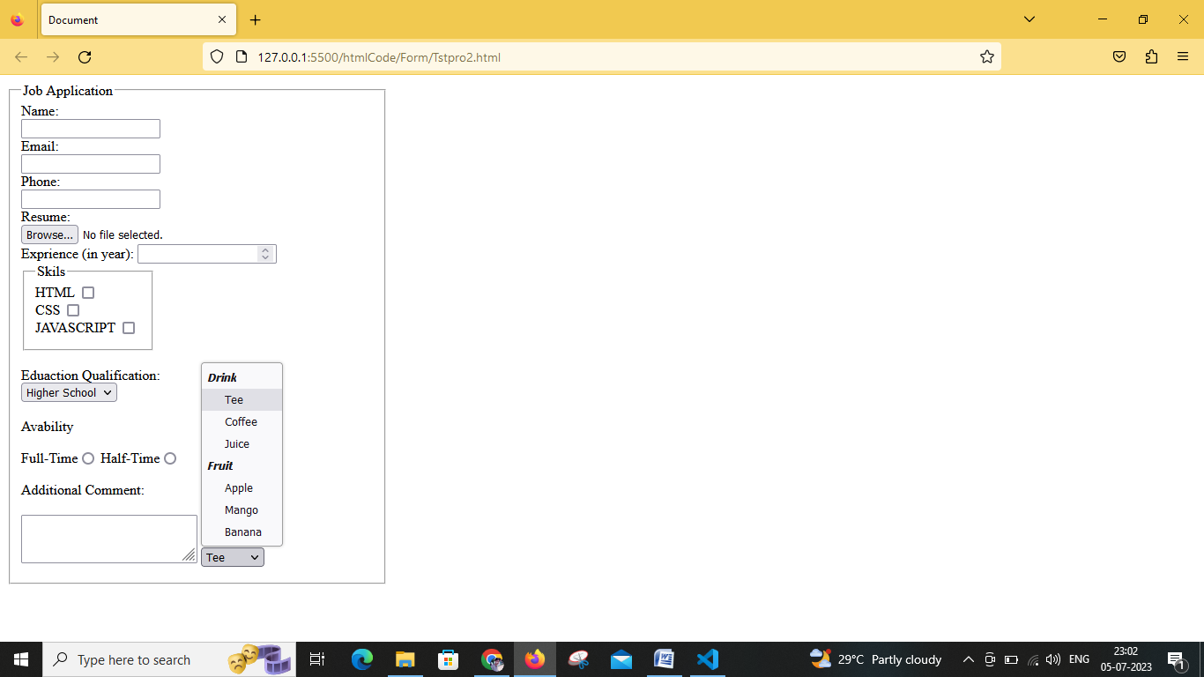

**The <label> Element**

The <label> tag defines a label for many form elements. Basically label tag is use to identifies the input element means which type of input element are given.

**Note**

The for attribute of the <label> tag should be equal to the id attribute of the <input> element because we need to mapped or link label tag with the input element. so we need to follow the rule.

*<*label for="ram"*>*Username*</*label*>*

*<*input type="text" id="ram"*>*

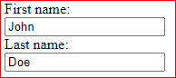

here first name and last name is label to identifies input box.

### [HTML< fieldset> tag](https://www.w3schools.com/tags/tag_fieldset.asp)

The <**fieldset**> tag is used to group related elements in a form. The <**fieldset**> tag draws a box around the related elements. The [<legend> tag](https://www.geeksforgeeks.org/html-legend-tag/#:~:text=The%20legend%20tag%20is%20used,for%20the%20element.) is used to define the title for the child’s contents.